Unit 7 So much to do before we travel! Period 6
Topic |  | Unit 7 Basic Module 2 (by the Higher Education Press)
Type of Lesson
  Unit task | Time | 45 mins
Analysis of the teaching material |  | 本课时系教材《英语2》（基础模块 高教版）第七单元的第六课时，该课内容是本单元的单元任务，即让学生能够运用所学语言完成一个真实的任务：为游客制作一座城市的旅游手册。
Analysis of the Students |  | 该课的授课对象是是中职旅游管理专业的学生，该班的学生已经过一个多学期专业课的学习，对于中国地理与旅游城市文化有了不错的认识与了解，同时经过lead-in,listening&speaking,reading&writing的学习，学生对于单元旅游词汇和句型有了很好的积累，但学生在课堂中用英语解决问题、完成实际任务时，表现得不够自信。因此还需给学生提供足够的脚手架，让学生在分工协作中学会用英语思考、表达、解决问题。
Teaching Objectives |  | Knowledge aims：  Students can master following expressions by making the best travel brochure.  the Great Wall/the Summer Palace/the National Grand Theatre/the Tian’anmen Square/the Forbidden City/ Beijing Duck/wonder/lotus/Beijing Opera/flag-raising ceremony  we can start the day at--------  we will----------  Ability goals：  Students can understand the passage well;  Students can create the travel brochure about their dream city;  Ss can introduce their own travel brochure to the tourists as a guide  Emotion & attitude goals：  Students can love the nature and love our country;  Ss can build the confidence of being a Chinese  Core competences:  Students can prepare themselves for the future career: to design the tour route,to serve the foreign tourists politely;  Students can improve their information accomplishment through group activities on the platform.
Teaching important point |  | Students can master some key expressions by making the best travel brochure;  Ss can talk about the travel brochure
Teaching difficult point |  | Students can make the best travel brochure with the key expressions;
Teaching methods |  | Communicative teaching, Task-based teaching, Situational teaching
Learning strategies |  | Individual learning,  Cooperative learning(Pair work, group work)
Teaching aids |  | Multimedia, PPT
Teaching preparations |  | Watch a micro-lesson<a travel brochure>,let students get a general idea of a travel brochure;  Ask students to find out the pictures of the spots in your dream city and upload them to the platform;  Divide students into groups and talk about the activities they would like do when visiting the dream city.
Teaching Procedures
Steps/ (Time) | Activity |  | Purpose
Step One Pre-task activities  (3m) | 1.Ask students questions:  Do you like traveling?  Where have you been before?  Where will you go this summer vacation?  Show students a map of China and let them guess: where will I go during the summer vacation? |  | To arouse the students’ interest and get ready for the topic.  To help students keep interest in the class.
Step Two While-task  Activities  (20m) | 1.Assign today’s task to the whole class:  ‘To make the best travel brochure’。  2.Create a real situation for students:  Teacher says ‘ Today I’m not your teacher but the tour guide. Let’s have a trip to Beijing.’  Ask students to watch a video and answer the two questions.  a) What do you know about Beijing?  b) What is it famous for?  3. Let the students experience the trip to the city-Beijing.  a) Read the passage quickly and ask students to give a title to the passage.  A Two-day Tour Plan in Beijing  How do you know?(find key words or sentences in the passage)  b) Show students a map of Beijing and the route of the travel plan on the first day.  Ask them to figure out the places of interest on the map.  - Show them a clip of the Great Wall and ask them to complete the blanks.  It is the wall in the world.  Its shape looks like a huge .  What can we do at the Great Wall?  - Share a picture of the Summer Palace and locate the names.  What can we do at the Summer Palace ?  - Show them a clip of Beijing Opera,  Peking Opera is also called .  It has a long history with about years old .  What can we do at the the National Grand Theatre ?  C)Show the route of the second day on the map and write down the famous places.  Ask students to talk about the travel plan on the second day using the sentence patterns.  In the morning/afternoon/evening, we will go to . We can . |  | To help the students be clear about what they are going to do today.  To help students get a vivid impression of Beijing and help them express themselves freely.  To help improve the reading ability-skimming. Encourage them to find clues in the passage.  To help the students master the key expressions by reading paragraph2 and paragraph3 several times. During the reading, let students practise the reading strategy-scanning .  Also the pictures and clips of the famous places can help students get more about the city and know the history of the city. That can help students cultivate their cultural consciousness and patriotic emotion.  Help students talk freely and fluently about the travel plan on the second day to improve their speaking and writing abilities.
Step Three  Post-task activities.  (20m) | You and your friends work for a travel agency. Your manager asks you to design a two-day trip to a Chinese city. Work in groups and make a travel brochure of it.  A)Check the homework on the Superstar platform.  Ask students to share their dream city.  Name of the city:  Location of the city:  The city is famous for:  B) What information should a travel brochure include?  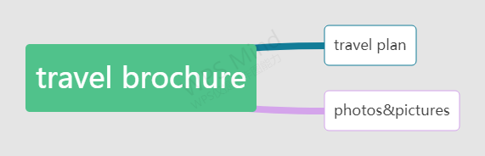  C)Students are asked to divided into four groups and talk about the travel plan of the dream city they have chosen.  Day1/Day2  D)Students make their own travel brochure on the computer and upload to the platform.  E)Show time:  Each group choose a representative to introduce the brochure as a guide to the rest of the class in turn.  Meantime, each group will be given scores by other groups and also give self-assessment according to the assessment form. |  | Create a real situation to motivate students to make a travel brochure and introduce it to the foreign tourists.  Group work help them cooperate with each other better .  Help the students to improve their intonation and tone. And cultivate their service awareness in the future career-how to serve tourists politely and correctly.  The assessment form can make students be more active in learning and speaking.
  Time | Places to go | Activities
  Morning
  Afternoon
  Evening
Step Four Summary  (1m) | Let the students recall what they have learnt in the unit. |  | To help the students consolidate the important contents in this period
Step Five  Homework  (1m) | Assign the homework to the class:  1)To learn the key expressions and sentences by heart.  2)To make the travel brochure better
教学反思 | 该课内容是完成单元任务：制作一个旅游手册。课前利用学习通教学平台让学生自由分组，让学生观看微课视频，了解“旅游手册”的内容；让学生分组查找中国城市的景点资源并上传至学习通，为课堂活动做好充分准备。课堂上为学生提供一篇北京二日游的计划书，让学生在各种阅读活动中知晓北京及北京景点文化，从而熟练掌握介绍城市景点和活动的语言和句型，为各小组制作旅游手册奠定坚实的语言基础。在语篇阅读中培养文化意识和提高思维能力，使学生能够作为作为导游熟练向外国游客介绍中国城市。课前、课中、课后的活动都践行以学生为中心的理论，关注学生核心素养的培养，让学生在旅游情境中感受“导游”的工作职责，在分工协作中体会学习的乐趣。  学生学情了解：  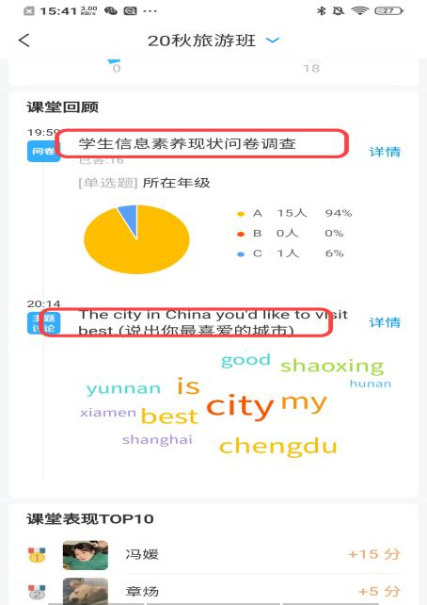  学生小组活动：  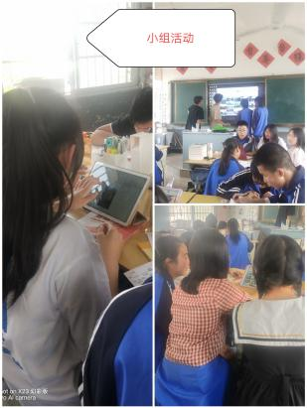  学生小组的景点图片：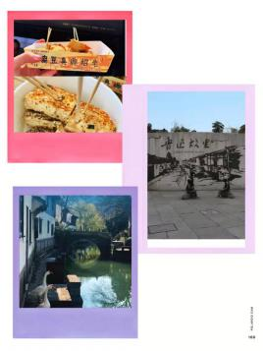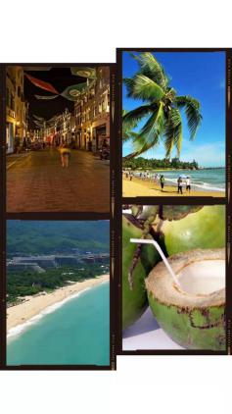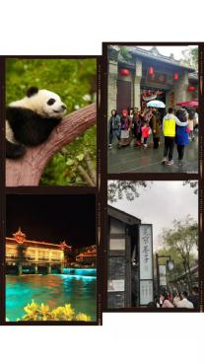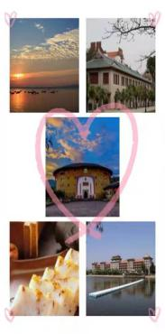  学生小组的作品（旅游手册）：  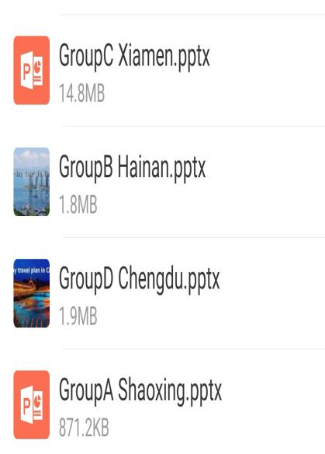  课堂整个教学过程都较为流畅，就是学生小组作品呈现时，因为操作的原因，还有一组作品还未上传到学习平台，使得后面作品评价未完整。在时间的把控上还需精心设计，以达到课堂效果的最佳。

